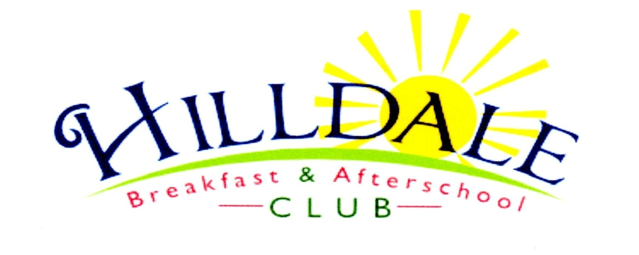
Hillside Avenue Primary and nursery School
Hillside Avenue
Norwich
NR7 0QW
Data Protection Agreement
Dear
Child’s name:-

Would you please authorise Hilldale to share information about your child with the school they attend where it is relevant to your child’s care and learning needs and also any safeguarding issues or concerns we may have. This would include corresponding with the teachers and head of your child’s school. This permission will only continue while your child is attending Hilldale.
Please tick the relevant box below.
I do wish for information to be shared. | I do not wish for information to be shared.

Signed by the parent/carer:-
Date: -
Have the parents received a copy of this agreement: -

Yes No

